ARE6641 Student Research Profile

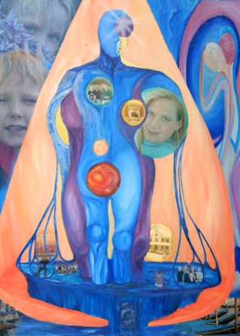

Stephanie Wirt
Art & Photography Teacher
Powhatan High School
(804) 794-0535
(804) 839-7375
Stephanie.wirt@powhatan.k12.va.us

Research interests
Interdisciplinary instruction to foster critical thinking * Engaging student learning through the use of instructional technology * Sources for artistic inspiration

Research Biography
Here, provide a 100-word biography of your research/scholarship/creative activity.

Degrees
2007 BFA K-12 Art Education, Longwood University

Key Professional Appointments
- 2011 – Powhatan High School Art Department Chair
- (1999-Present) Art and Photography Teacher grades 9-12 Powhatan High School, Powhatan, VA
- (2000-2007) Technology Trainer Powhatan County Public Schools
- (1998-99) Department of Correctional Education - Art Teacher - Beaumont Juvenile Correctional Facility
Selected Presentations, Exhibitions, Performances
- August 2011 – Printmaking and Image Transfers: In-service workshop for k-12 art teachers
- Abstract Painting in Action - Online Gallery of processes and artworks. http://wirtpaintings.blogspot.com/
- November, 2006. Versions and Variations Solo Show of paintings and Photography, Ty & CO, Powhatan, VA.

Grants
- 2008 An American In Paris - Enhancement of Art History Curriculum
- 2006 Fine Art and Foreign Language Integration Grant
- 2002-08 Recipient of Multiple Academic and Technical Education integration grants through the High Schools That Work (HSTW) initiatives.

Curriculum Vitae

